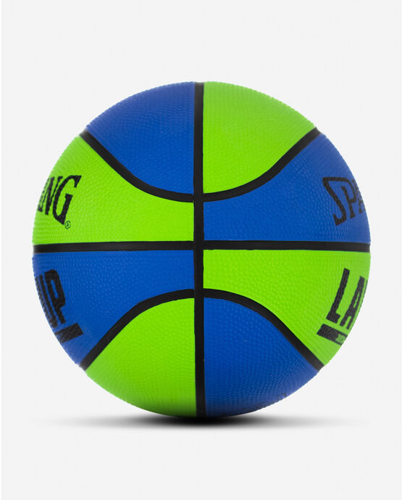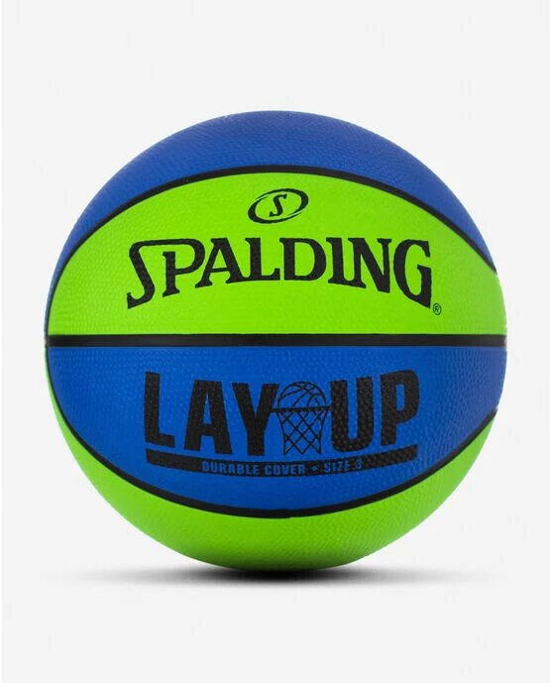

SPALDING LAYUP MINI RUBBER BASKETBALL

The Spalding Mini Rubber Outdoor basketball is made for pint-sized ballers or arcade-style games. It has the look and feel of a regular outdoor ball, but is sized to fit hoops with a 12-inch inside diameter.

**DETAILS:**

* Mini Size: 22"
* Performance outdoor rubber cover
* Shipped inflated and game-ready
* Designed for outdoor play
* Backed by Spalding's Warranty